**mRNA vaccine manufacturing**

Anirudh V Veliyur(20CHE191)

Shauryaraj Jilkar(20CHE172)

**Introduction**

* Vaccines are one of the most important tools in public health and play an important role in infectious diseases control.
* Owing to its precision, safe profile and flexible manufacturing, mRNA vaccines are reaching the stoplight as a new alternative to conventional vaccines.
* Additionally, mRNA vaccines are being studied in the clinic to treat a number of diseases including cancer, HIV, influenza and even genetic disorders.

**Principle**

Construction of mRNA vaccines requires the insertion of the encoded antigen in a DNA template from where the mRNA is transcribed *in vitro*. Unlike DNA, mRNA only needs to reach the cytosol, where it will be translated into the antigen *in vivo,* using the cell machinery. This way, any desired sequence can be designed, produced *in vitro,* and delivered to any type of cell. Inside the cells, RNA is recognized by endosomal or cytosolic receptors, which can lead to the activation of the type I interferon (IFN-I) pathway, and to the promotion of the production of chemokines and proinflammatory cytokines. These signal molecules lead to antigen-presenting cell (APC) activation and, subsequently, to a strong adaptive response.

**Advantages**

* Unlike attenuated or inactivated vaccines, mRNA is precise as it will only express a specific antigen and induce a directed immune response.
* It promotes both humoral and cellular immune response and induces the innate immune system
* Compared with DNA-based vaccines, mRNA is more effective, since expression does not require nuclear entry, and safer, since the probability of random genome integration is virtually zero

**Manufacturing**

* The increased demand for mRNA vaccines requires a technology platform and cost-effective manufacturing process with a well-defined product characterization. Large scale production of mRNA vaccines consists in a 1 or 2-step *in vitro* reaction followed by a purification platform with multiple steps that can include DNase digestion, precipitation, chromatography or tangential flow filtration.
* One of the most important advantages of mRNA over conventional vaccines is its relatively simple manufacturing.
* Currently, a well-established manufacturing platform is still lacking and a number of combinations of steps is possible.
* These can be grouped into
  + - 1. Upstream processing, which comprises the enzymatic generation of mRNA
      2. Downstream processing, which includes the unit operations required to purify the mRNA product
* These are complemented with LNP formulation and Fill-to-Finish steps.

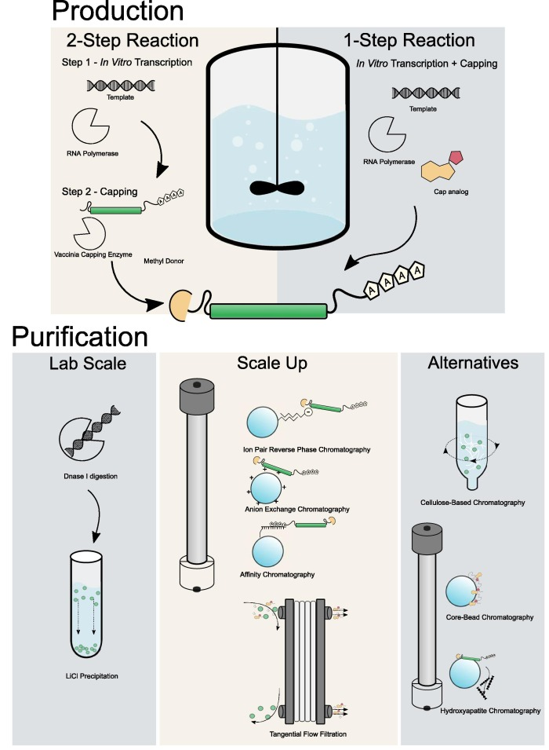

**Sequence of operations in the manufacturing process**

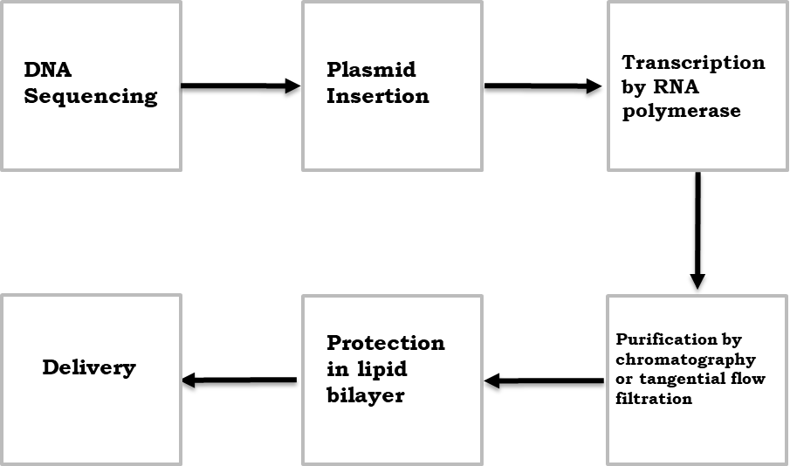

**Description of the Manufacturing process**

1. DNA Sequencing

Production of mRNA-based therapeutics and vaccines typically or commonly begins with a pDNA template that contains a DNA-dependent RNA polymerase promoter and the corresponding sequence for the mRNA construct. Given the central role of the pDNA construct, its design and purity are important factors for optimizing the mRNA product.

The mRNA construct is designed to ensure efficient expression of the gene of interest. Stability, gene expression and efficient protein translation depend upon several structural elements

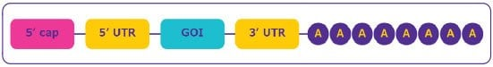

* The cap region at the 5’ end of the sequence is essential for mRNA maturation and allows the ribosome to recognize the mRNA for the efficient protein translation. The cap also stabilizes mRNA by protecting it from nuclease digestion.
* The untranslated regions (UTRs) located at the upstream and downstream domains of the mRNA coding region are affecting translation efficiency, localization and stability and can be utilized for efficient protein expression.
* The open reading frame or coding sequence regions contains the gene of interest (GOI).
* The poly-(A) tail is crucial for protein translation and mRNA stability by preventing digestion by 3’ exonuclease.

1. Plasmid Insertion

* The required pDNA is amplified within bacterial cells, typically E. coli, and subsequent purification steps yields a pure, concentrated, circular pDNA. The pDNA is then linearized to serve as a template for the RNA polymerase to transcribe the desired mRNA.
* Linearization is required to avoid transcriptional readthrough events that may generate undesired forms of mRNAs leading to additional impurities that would need to be removed. Linearization is achieved by mixing the plasmid DNA with a restriction enzyme in a reaction buffer4 and subsequent incubation at 37 °C for 4 hours. Optionally, the reaction is stopped by the addition of EDTA or heat inactivation at 65 °C.
* Impurities such as the restriction enzyme, BSA, DNA fragments, endotoxins and others are then removed. Most of the lab scale processes use a solvent extraction technique and this not applicable for GMP production environments.
* As an alternative, tangential flow filtration (TFF) and chromatography are efficient impurity removal techniques for this purification step.

1. Transcription by RNA polymerase

* The next step is in vitro transcription during which the linearized pDNA, serving as the DNA template, is transcribed into mRNA.
* This enzymatic reaction uses elements of the natural transcription process, including RNA polymerase and nucleotide triphosphates.
* Following transcription, the final mRNA structure requires a 5’ cap structure for stability and efficient transduction in the cell.
* The cap can be added in two ways – either co-transcriptionally or enzymatically.
  + Co-transcriptional capping is usually accomplished by adding cap analogs and guanosine triphosphate (GTP) in the transcription mix at a ratio of four cap analogs for one GTP. Following an incubation step at 37 °C, the DNA template is typically degraded by the addition of DNases; the resulting small DNA fragments can then be easily separated from larger mRNA molecules by tangential flow filtration (TFF). Another option to remove the DNA template includes the utilisation of a chrome step (e.g. Poly (dT) capture). In the latter case the DNA template does not need to be digested, which avoids the risk of small DNA fragments hybridizing to the mRNA. Co-transcriptional capping is less expensive and faster than enzymatic capping as it is performed during the transcription step, in the same reactor mix. However, efficiency and yield are lower and it can generate non-capped impurities as GTP can bind to the mRNA sequence instead of the cap analogs. In addition, the cap analogs can be incorporated in the reverse orientation. To overcome this, some antireverse cap analogs (ARCA) have been developed to prevent this reverse incorporation of a 5’ cap, leading to higher translation efficiency.
  + Enzymatic capping is performed after mRNA purification from the *in vitro* transcription mixture. This reaction usually uses a vaccinia virus-capping enzyme to add the capping structure to the mRNA structure. While enzymatic capping has a very high capping efficiency, it is more expensive and requires an extra unit operation.

1. Purification of mRNA

* Following the *in vitro* transcription step, mRNA is purified from the impurities and materials used in the previous steps including endotoxins, immunogenic double stranded RNA (dsRNA), residual DNA template, RNA polymerase and elemental impurities.
* TFF allows efficient separation of mRNA from smaller impurities that are not retained by the membrane; molecular weight cut-offs ranging from 30 to 300 kDa can be used based on the size of the mRNA. With TFF it is possible to purify, concentrate and diafilter the product within the same unit operation. At this stage, the mRNA will need to be in the appropriate buffer, either for enzymatic capping or chromatography. An important consideration when using TFF, however, is that small DNA fragments can hybridize to the mRNA, generating additional impurities.
* A number of chromatography techniques can be used as an alternative to TFF and include reverse-phase ion pair, anion exchange and affinity chromatography using poly(dT) capture.

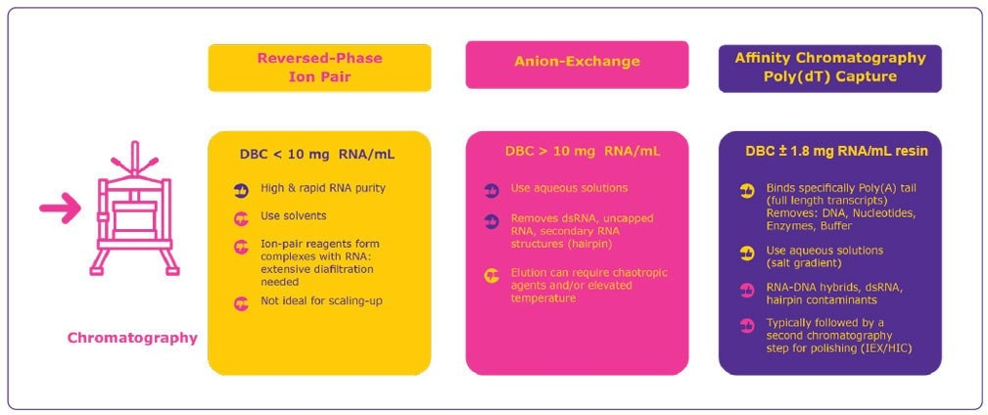

1. Protection in bilipid layer & Delivery

* Delivery tools are equally important in the effectiveness of mRNA vaccines and therapeutics. After the final mRNA purification step, the next consideration is the delivery mechanism.
* Lipid nanoparticles (LNP) are most commonly used for mRNA delivery; each lipid nanoparticle consists of four different lipids allowing the mRNA to be carried in it and protected from degradation.
  + **Cationic/ionizable lipids** are required for encapsulating the RNA via electrostatic interactions. Delivery to hepatocytes (for boosting or silencing of protein expression) requires ionizable lipids (passive targeting, endosomal release) whereas uptake by immune cells is much easier. It also works with strong cationic lipids. These lipids are also responsible for efficient release of the RNA into the cytoplasm. The structure of cationic lipids has a major impact on the activity of the LNP, its toxicity and biodistribution, which then influences potential toxicity effects in the body.
  + **Polyethylene glycol (PEG) lipids** provide colloidal stability and prevent protein binding to the particle, thereby shielding it from the immune system and achieving longer circulation. The length of the PEG chain and fatty acid chains determine the circulation lifetime and fusogenicity, or how well the particle can fuse with the endosomal membrane of the LNP. If the goal is prolonged circulation, longer fatty acid chains can be used, such as polyethylene glycoldistearoylglycerol (DSG PEG 2000). The concentration of PEG also has an effect on the size of the particle. In addition, use of PEG may result in the formation of antibodies against it, potentially rendering the immunization useless.
  + **Neutral/anionic lipids** provide structural stability and play a role in defining the fusogenicity and biodistribution. 1,2-dioleoyl-sn-glycero-3- phosphoethanolamine. For example, a recent study[**1**](https://www.sigmaaldrich.com/technical-documents/articles/white-papers/manufacturing-strategies-for-mrna-vaccines#ref) showed LNPs containing 1,2-dioleoyl-sn-glycero- 3-phosphoethanolamine (DOPE), which plays an important role in endosomal release, led to enhanced delivery of mRNA to the liver as compared to 1,2-distearoyl-sn-glycero-3-phosphocholine (DSPC). Recent studies[**2**](https://www.sigmaaldrich.com/technical-documents/articles/white-papers/manufacturing-strategies-for-mrna-vaccines.html#ref) suggest that these helper lipids also assist in the stable encapsulation of the RNA.
  + **Cholesterol** is used to modulate the bilayer density, fluidity and uptake (raft formation) of the LNP. While there are animal-derived and synthetic versions of cholesterol available in the market, synthetic cholesterol offers several advantages including higher purity, lack of animal derived molecules such as prions, scalability, and highly consistent quality.
* **Considerations for lipid selection** Lipids should be chosen based on the delivery route in mind to achieve maximum efficacy and optimal biodistribution. In addition to the choice of lipids, the ratio between the individual lipids it is an important component to finetune, as it has a direct impact on the bilayer fluidity and the fusogenicity of the LNP. Several critical aspects must be considered when selecting the lipid. Lipid type, source and quality have a direct impact on the impurity profile and properties such as the particle characteristics, stability and release profile is the final formulation. To achieve reproducible results with the final formulation, consistent quality of lipids is required, which is dependent on the quality of the raw materials used to synthesize the lipids and appropriate material characteristics of the lipid itself.
* The purified mRNA can be formulated into the delivery particle via different techniques. In the commonly used solvent injection technique, lipids are dissolved in a solvent such as ethanol and rapidly mixed in an aqueous, low pH buffer containing the mRNA using a crossflow mixing or microfluidic mixing is to create the LNPs. The low pH buffer is then diafiltered into a neutral buffer and ultrafiltration is used to concentrate the particles.
* LNPs have a very good stability, structural plasticity and enhanced gene delivery compared to other delivery systems. They increase the transfection rate compared to naked mRNA, allow for intravenous injection without the risk of being degraded by RNases present in the bloodstream and enable active targeting if specific ligands are incorporated.
* Disadvantages of LNPs include the fact that they may require cold chain logistics. In addition, sterile filtration is not always possible with LNPs and in such cases alternatives, such as gamma irradiation, heat sterilization, high-pressure sterilization or closed processing must be considered.

**Chemicals/Materials required**

1. Sequenced plasmid DNA: This is a double stranded circular entity that encodes the gene that is required to produce the antibody, to counteract the antigen.

2. Nucleotide triphosphates: RNA polymerase will act on these species to polymerize them in a fashion complimentary to the linearized plasmid DNA temlate.

3. Buffer:

● Tris base: It is used to maintain a stable pH for the transcription step, as it can reversibly undergo proton exchange on N atom.

● Magnesium Chloride: Magnesium ions allow the RNA polymerase to carry out the task of forming an RNA template by binding to the specific RNA polymerase.

● HCL/ NaCl is used to obtain the desired pH.

4. EDTA: This is a chelating ligand that will bind to all available magnesium ion.

5. Cap analogues: Post Transcription, methylating agents are used to cap the ends of an mRNA molecule, in preference to g3P. These protect the RNA from digestion by enzymes.

6. LiCl: it is an aide to the action of DNAses that break stray DNA into smaller fragments for separation from the mRNA.

7. Solvents: If ion exchange chromatography is being used to purify the mRNA, then usually the solution is eluted with a solvent that is best suited for the requirements of the chromatography as it can aid in the separation of RNA and DNA due to the difference in charge to size ratio.

8. Lipid Nanoparticles:

● Cationic/ionizable lipids: These encapsulate RNA by polar attractive forces and aid in delivery into the cells.

● Polyethylene glycol lipids: It stabilizes the colloidal particles and protects them to ensure circulation for longer duration

● Neutral/anionic lipids: These alter the fusogenisity and biodistribution.

● Cholesterol: It controls the bilayer, density, fluidity and uptake.

9. Ethanol and low pH aqueous buffer: It is used to transfer the mRNA in the buffer to the lipid nanoparticles in ethanol so that they can be delivered into the body.

**Enzymes and Organisms**

1. E coli: The plasmid DNA template is amplified in bacterial cells, particularly E. coli to give pure circular pDNA.

2. Restriction Enzymes: These are needed for linearization of the DNA molecule to avoid transcriptional read through events. This involves cutting the pDNA at a required site and unfolding the circular double strand.

3. RNA polymerase: It performs the task of transcription from DNA to mRNA in the presence of Mg ions and a buffer soln.

4. Vaccinia virus capping enzyme: It is used to attach a cap to the purified mRNA.

5. DNAse: This is used to cut stray DNA present along with mRNA into smaller pieces so that it can be separated out.

**Process conditions**

1. Preparation of pDNA

Plasmids are constructed in vitro by digesting DNA fragments with restriction enzymes at restriction sites and then ligating the resulting fragments. This is mostly done at 37 °C. Sometimes it can be done at other temperatures based on the restriction endonuclease used.

Examples of DNA templates to be used in the methods of the invention include, e.g., pJ344:91543 (including a GCSF gene and Xbal site) and pJ204:109475 (including a Factor IX gene and a SAPI site).

It is then produced in large quantities using a microbial source such as E. coli through fermentation. The media for fermentation generally used are LB media, super broth media and super broth media with glycerol. E. coli cells could be harvested into a pellet by batch centrifugation using 4,500–6,000 g for ~15–20 min (at room temperature or ~4 ºC).

Then the cell is disrupted to obtain the pDNA through chemical (alkali, detergents, enzymes, osmotic shock) and physio mechanical (heat, shear, agitation, ultra-sonification, and freeze-thawing) lysis. In alkaline lysis method, cells are treated at specific, narrow range of pH around 12.

Precipitation/flocculation is then carried out to remove the host cell contaminants from the pDNA manufacturing process. Neutralization can be done using a high concentration of sodium or potassium acetate with or without surfactant, RNase, or CaCl2. This step causes precipitation of detergent solubilized proteins including high molecular weight genomic DNA. RNase can be added into the neutralization buffer for degradation of high molecular weight RNA impurities (RNA could be present at least 20X amount of pDNA). Some chaotropic salts, such as lithium chloride, ammonium acetate, and calcium chloride have the additional advantage of precipitating high molecular weight RNA together with the proteins. Polyethylene glycol (PEG) and polyethylenimine (PEI) can also be used for precipitation of genomic DNA.

Rapid precipitation occurs with high-salt buffer (such as sodium or potassium acetate at concentration of 0.7 M–3.0 M and pH ~5–7.5, with/without 0.8–1.5% CaCl2) in the presence of a detergent (1% SDS). A low-cut off PEG precipitation (at 4% w/v) can also be used for precipitation of genomic DNA with up to 20% (w/v) of the precipitate formed during the step. Homogenous mixing during neutralization and precipitation is critical to maintain pDNA quality.

1. Linearization of pDNA

Linearization is achieved by mixing the plasmid DNA with a restriction enzyme in a reaction buffer and subsequent incubation at 37 °C for 4 hours. Optionally, the reaction is stopped by the addition of EDTA or heat inactivation at 65 °C.

Impurities such as the restriction enzyme, BSA, DNA fragments, endotoxins and others are then removed. Most of the lab scale processes use a solvent extraction technique and this not applicable for GMP production environments.

As an alternative, tangential flow filtration (TFF) and chromatography are efficient impurity removal techniques for this purification step.

1. In-vitro transcription

In general, the reaction takes place in a tube with inert and non-adsorptive walls (silicone or Teflon) that hosts the DNA template, a transcription buffer (e.g., HEPES or Tris HCl; NaCl, magnesium, dithiothreitol (DTT) and/or spermidine), natural or unnatural (modified) NTPs, an RNase inhibitor and an RNA polymerase. As has been mentioned, the polymerase may be a phage RNA polymerase (SP6, T3 or T7 RNA polymerases are common choices), and/or mutant polymerases such as, polymerases able to incorporate modified nucleic acids. The reaction is incubated in suitable conditions, under constant mixing at 37 C. The in vitro transcription (IVT) enzymatic reaction used to generate mRNA relies on T7, SP6 or T3 RNA polymerases to catalyse the synthesis of the target mRNA from the corresponding DNA template In-vitro transcription is performed at room temperature or at 37°C. Lowering the temperature to ~16°C or even 4°C can sometimes improve transcription.

The in vitro transcription reaction includes the following: an RNA polymerase, e.g., a T7 RNA polymerase at a final concentration of, e.g., 1000-12000 U/mL, e.g., 7000 U/mL; the DNA template at a final concentration of, e.g., 10-70 nM, e.g., 40 nM; nucleotides (NTPs) at a final concentration of e.g., 0.5-10 nM, e.g., 7.5 nM each; magnesisum at a final concentration of, e.g., 12-60 mM, e.g., magnesium acetate at 40 mM; a buffer such as, e.g., HEPES or Tris at a pH of, e.g., 7-8.5, e.g. 40 mM Tris HCl, pH 8.

In some embodiments 5 mM dithiothreitol (DTT) and/or 1 mM spermidine is included. In some embodiments, an RNase inhibitor is included in the in vitro transcription reaction to ensure no RNase induced degradation during the transcription reaction. For example, murine RNase inhibitor can be utilized at a final concentration of 1000 U/mL, In some embodiments a pyrophosphatase is included in the in vitro transcription reaction to cleave the inorganic pyrophosphate generated following each nucleotide incorporation into two units of inorganic phosphate. This ensures that magnesium, which is essential for transcription, remains in solution and does not precipitate as magnesium pyrophosphate.

For example, an E. Coli inorganic pyrophosphatase can utilized at a final concentration of 1 U/mL.

The in vitro transcription reaction is allowed to proceed, for example, under constant mixing at 37°C for 4 hours.

1. Capping of the RNA

The RNA transcript is enzymatically capped at the 5’ end after in vitro transcription. Enzymatic 5’ capping is performed as follows. S-adenosylmethione chloride*2HCl is dissolved at 20mM in 5mM HC1 10/90 v/v% ethanol/ water as a prepared stock. RNase inhibitor are utilized as a safeguard to ensure no RNase degradation is observed during the reaction. The final IX buffer conditions consist of the following: 50mM Tris HCl pH 8, 5mM KC1, 1mM MgC12, and 1mM dithiothreitol. The reaction is run under constant mixing at 37°C for 2 hours. Enzymatic capping is of considerably higher efficiency than performing co-transcription through the use of dinucleotide cap analogs.

1. Purification and Concentration of product mRNA

Ethanol precipitation is useful for concentrating RNA solutions. Ethanol and isopropanol are both commonly used for the precipitation of nucleic acids. In the presence of relatively high (0.1 to 0.5 M) concentrations of monovalent cations, ethanol induces a structural transition in nucleic acid molecules, which causes them to aggregate and precipitate from solution. However, most salts and small organic molecules are soluble in 70% ethanol; thus, ethanol precipitation and washing of the pellet in 70% ethanol will effectively desalt DNA. Lithium chloride is used for precipitation of RNA, as it has the benefit of being unable to effectively precipitate carbohydrate, protein, or DNA. Stock concentration of LiCl is 8M and working concentration required is 0.8M.

1. LNP Delivery

The 1,2-Diastearoyl-sn-glycero-3-phosphocholine (DSPC) was purchased from Genzyme. Cholesterol was obtained from Sigma-Aldrich. 1,2-dimyristoyl-sn-glycero-3-phosphoethanolamine-N-[methoxy(polyethylene glycol)-2000] (ammonium salt) (PEG DMG 2000) was obtained from Avanti Polar Lipids. A modified ethanol dilution process was used to produce the LNP formulation with the following molar ratios of lipid components: DSPC: cholesterol: PEG-DMG 2000: DLinDMA 10:48:2:40 molar percent. An 8:1 N:P molar ratio (nitrogen on DlinDMA to phosphate on RNA) and 100 mM citrate buffer (pH 6) were used for the formulations. In the first step of the in-line mixing, equal volumes of lipid (in ethanol) and RNA in buffer were mixed, through a T-junction via a KDS-220 syringe pump (kdScientific), and a third syringe with equal volume of buffer was added simultaneously to the lipid/RNA mixture. After 1 h equilibration at room temperature, the mixture was further diluted with 1:1 vol/vol citrate buffer. Next, the LNPs obtained were concentrated and dialyzed against 1× PBS using tangential flow filtration (TFF) (Spectrum Labs) with polyethersulfone (PES) hollow fiber membranes with a 100-kDa pore size cutoff and 20 cm2 surface area. For in vitro and in vivo experiments, formulations were diluted to the required RNA concentration with 1× PBS (Teknova).

**Enzymatic data from Michaelis-Menten Plot**

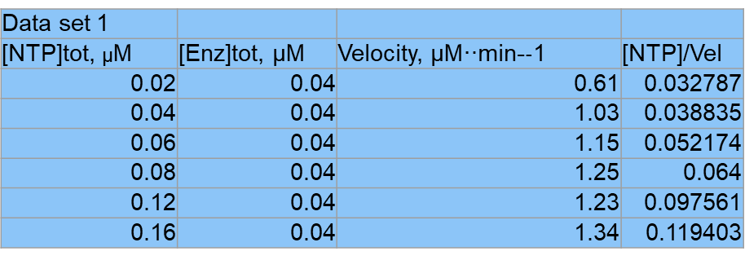

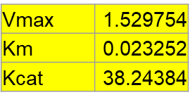

**Optimum conditions**

Temp range: - 38 - 42 °C

pH range: - 7.8 - 8.2

Mg2+ conc: - 8x10-3 M

Mn2+ conc: - 2x10-3 M

**Mass Balance**

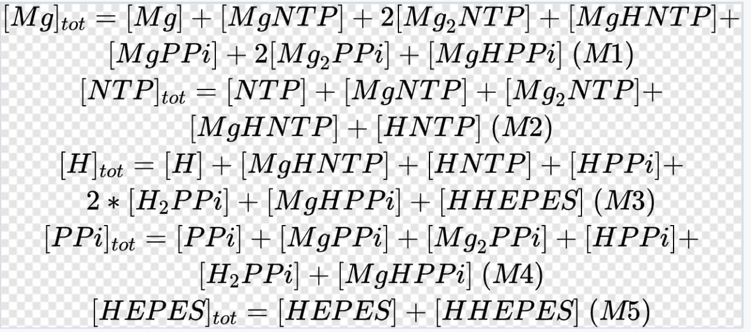

**Equilibrium constraints**

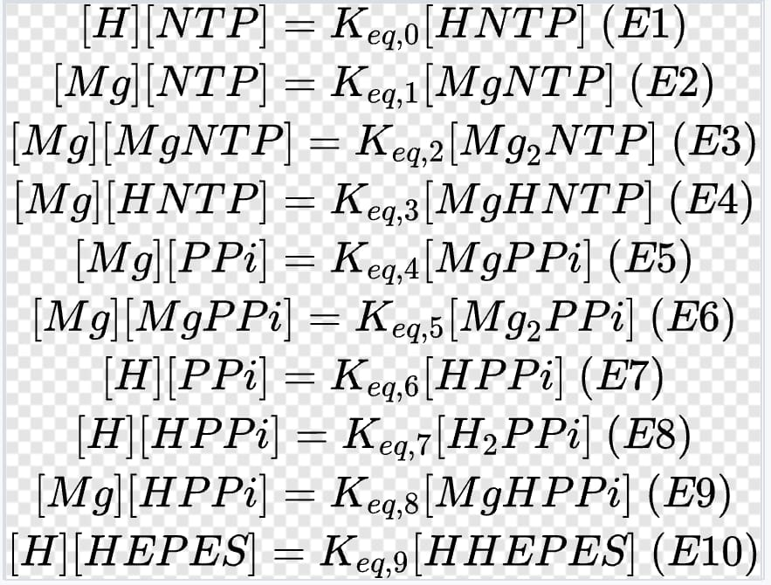

**Kinetic expressions**

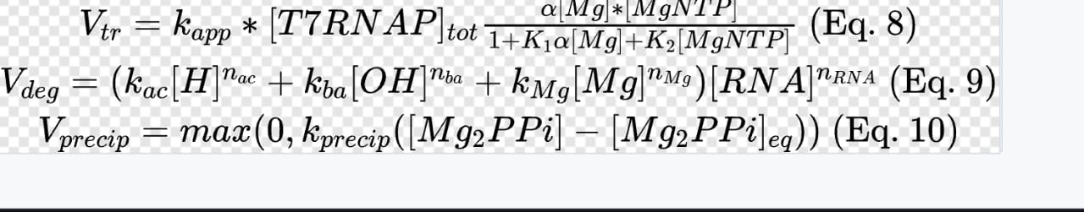

**Differential equations**

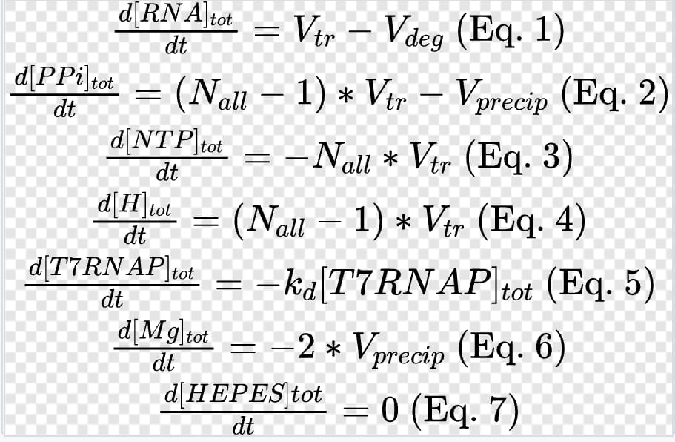

**Python code for ODEs**

import numpy as np  
import scipy.integrate as scint  
import xlwings  
from scipy.optimize import fsolve  
  
wb = xlwings.Book("mRNA transcripts.xlsx")  
sheet = wb.sheets("ODE")  
def read_parameters(boolcalc = False):  
   
 RNA_0 = sheet.range("rna").value  
 mg_0 = sheet.range("mgleft").value  
 ntp = sheet.range("ntptotal").value  
 tmax = sheet.range("tmax").value  
 t7_0=sheet.range("polymerase").value  
 h_0=sheet.range("hplus").value  
 oh_0=sheet.range("hydroxyl").value  
 mgntp_0=sheet.range("mgntp").value  
 HEPES_0=sheet.range("HEPES").value  
 hntp=sheet.range("hntp").value  
 mg2ntp=sheet.range("mg2ntp").value  
 mghntp=sheet.range("mghntp").value  
 Nall=sheet.range("nall").value  
   
 return RNA_0,mg_0,ntp,t7_0,h_0,oh_0,mgntp_0,HEPES_0,Nall,tmax,hntp,mg2ntp,mghntp  
   
k1=sheet.range("firstk").value  
k2=sheet.range("secondk").value  
kapp=sheet.range("kapp").value  
kac=sheet.range("kac").value  
print (k1)  
print (k2)  
print (kapp)  
print (kac)  
  
def model(A,t,t7,oh,HEPES,nall,hntp,mg2ntp,mghntp,mgntp,mg):  
 [rna,ntptot,htot]=A  
 h=(10**-7.5)  
 ntp=0.0001  
 S0=[h,ntp,hntp,mg,mgntp,mg2ntp,mghntp]  
 S0=fsolve(massbalance,S0,args=(ntptot,htot))  
 vtr=kapp*(t7)*(mg*mgntp/(1+(k1*mg)+(k2*mgntp)))  
 vdeg=kac*h*rna  
 RNAd=vtr-vdeg  
 ntpd=-1*nall*vtr  
 hd=(nall-1)*vtr  
 print ("model executed")  
 return [RNAd,ntpd,hd]  
  
def solve():  
 rna1,mg1,ntp1,t7,h1,oh1,mgntp1,HEPES1,nall1,tm,hntp,mg2ntp,mghntp= read_parameters(boolcalc=True)  
 npts = len(sheet.range("tstart:tend"))  
 tend = sheet.range("tmax").value  
 t = np.linspace(0, tend, npts)  
 arr0=[rna1,ntp1,h1]  
 solution = scint.odeint(model,arr0,t,args=(t7,oh1,HEPES1,nall1,hntp,mg2ntp,mghntp,mgntp1,mg1))  
   
 rnat = solution[:,0]  
 ntpt = solution[:,1]  
 ht=solution[:,2]  
   
   
 sheet.range("tstart").value = t.reshape((npts,1))  
 sheet.range("rnastart").value = rnat.reshape((npts,1))  
 sheet.range("ntpstart").value = ntpt.reshape((npts,1))  
 sheet.range("hstart").value = ht.reshape((npts,1))  
 print ("solve executed")  
   
def massbalance(B,ntptot,htot):  
 [hplus,ntpleft,hntp,mg2ntp,mghntp,mgntp,mgleft]=B  
 z1= hplus*ntpleft-((10**-6.9)*hntp)  
 z2=(mgleft*ntpleft)-(mgntp*10**-4.42)  
 z3=(mgleft*mgntp)-(mg2ntp*10**-1.69)  
 z4=(hntp*mgleft)-(mghntp*10**-1.49)  
 z5=0.085-mgleft-mgntp-mghntp-(2*mg2ntp)  
 z6=ntptot-ntpleft-hntp-mgntp-mg2ntp-mghntp  
 z7=htot-hplus-hntp-mghntp  
 return z1,z2,z3,z4,z5,z6,z7  
   
   
  
if __name__ == "__main__":  
 parameters = np.array(read_parameters())  
 boolgo = True  
 while boolgo:  
 val = sheet.range("A1").value  
 if val == 1:  
 sheet.range("A1").value = ''  
 boolgo = False  
 else:  
 parametersnow = np.array(read_parameters())  
 if np.linalg.norm(parametersnow - parameters) > 1e-10:  
 parameters = parametersnow  
 solve()

**Excel sheet for executing ODEs**



|  |  |  |  |  |  |  |
| --- | --- | --- | --- | --- | --- | --- |
| tstart | rnastart | ntpstart | hstart | mg | mgntp | log h |
| 0 | 0 | 0.04080000000000000000 | 3.16228E-08 | 0.022754 | 0.019277 | -7.5 |
| 0.036697 | 6.39702E-09 | 0.04073598524333530000 | 6.404E-05 | 0.022775 | 0.019256 | -4.19355 |
| 0.073394 | 1.27851E-08 | 0.04067197048667060000 | 0.000128048 | 0.022796 | 0.019235 | -3.89263 |
| 0.110092 | 1.91644E-08 | 0.04060795573000580000 | 0.000192057 | 0.022817 | 0.019213 | -3.71657 |
| 0.146789 | 2.55347E-08 | 0.04054394097334110000 | 0.000256065 | 0.022838 | 0.019192 | -3.59165 |
| 0.183486 | 3.18962E-08 | 0.04047992621667640000 | 0.000320073 | 0.022859 | 0.019171 | -3.49475 |
| 0.220183 | 3.82488E-08 | 0.04041591146001170000 | 0.000384082 | 0.022881 | 0.01915 | -3.41558 |
| 0.256881 | 4.45926E-08 | 0.04035189670334690000 | 0.00044809 | 0.022902 | 0.019129 | -3.34863 |
| 0.293578 | 5.09276E-08 | 0.04028788194668220000 | 0.000512098 | 0.022923 | 0.019108 | -3.29065 |
| 0.330275 | 5.72537E-08 | 0.04022386719001750000 | 0.000576107 | 0.022944 | 0.019086 | -3.2395 |
| 0.366972 | 6.3571E-08 | 0.04015985243335280000 | 0.000640115 | 0.022965 | 0.019065 | -3.19374 |
| 0.40367 | 6.98796E-08 | 0.04009583767668800000 | 0.000704124 | 0.022987 | 0.019044 | -3.15235 |
| 0.440367 | 7.61794E-08 | 0.04003182292002330000 | 0.000768132 | 0.023008 | 0.019023 | -3.11456 |
| 0.477064 | 8.24704E-08 | 0.03996780816335860000 | 0.00083214 | 0.023029 | 0.019002 | -3.0798 |
| 0.513761 | 8.87526E-08 | 0.03990379340669390000 | 0.000896149 | 0.02305 | 0.01898 | -3.04762 |
| 0.550459 | 9.50261E-08 | 0.03983977865002910000 | 0.000960157 | 0.023071 | 0.018959 | -3.01766 |
| 0.587156 | 1.01291E-07 | 0.03977576389336440000 | 0.001024165 | 0.023093 | 0.018938 | -2.98963 |
| 0.623853 | 1.07547E-07 | 0.03971174913669970000 | 0.001088174 | 0.023114 | 0.018917 | -2.9633 |
| 0.66055 | 1.13794E-07 | 0.03964773438003500000 | 0.001152182 | 0.023135 | 0.018895 | -2.93848 |
| 0.697248 | 1.20033E-07 | 0.03958371962337030000 | 0.00121619 | 0.023156 | 0.018874 | -2.915 |
| 0.733945 | 1.26263E-07 | 0.03951970486670550000 | 0.001280199 | 0.023178 | 0.018853 | -2.89272 |
| 0.770642 | 1.32484E-07 | 0.03945569011004080000 | 0.001344207 | 0.023199 | 0.018832 | -2.87153 |
| 0.807339 | 1.38697E-07 | 0.03939167535337610000 | 0.001408215 | 0.02322 | 0.01881 | -2.85133 |
| 0.844037 | 1.44901E-07 | 0.03932766059671140000 | 0.001472224 | 0.023241 | 0.018789 | -2.83203 |
| 0.880734 | 1.51096E-07 | 0.03926364584004660000 | 0.001536232 | 0.023263 | 0.018768 | -2.81354 |
| 0.917431 | 1.57283E-07 | 0.03919963108338190000 | 0.001600241 | 0.023284 | 0.018747 | -2.79581 |
| 0.954128 | 1.63461E-07 | 0.03913561632671720000 | 0.001664249 | 0.023305 | 0.018725 | -2.77878 |
| 0.990826 | 1.69631E-07 | 0.03907160157005250000 | 0.001728257 | 0.023326 | 0.018704 | -2.76239 |
| 1.027523 | 1.75792E-07 | 0.03900758681338770000 | 0.001792266 | 0.023348 | 0.018683 | -2.7466 |
| 1.06422 | 1.81944E-07 | 0.03894357205672300000 | 0.001856274 | 0.023369 | 0.018661 | -2.73136 |
| 1.100917 | 1.88088E-07 | 0.03887955730005830000 | 0.001920282 | 0.02339 | 0.01864 | -2.71663 |
| 1.137615 | 1.94223E-07 | 0.03881554254339360000 | 0.001984291 | 0.023412 | 0.018619 | -2.70239 |
| 1.174312 | 2.0035E-07 | 0.03875152778672880000 | 0.002048299 | 0.023433 | 0.018597 | -2.68861 |
| 1.211009 | 2.06468E-07 | 0.03868751303006410000 | 0.002112307 | 0.023454 | 0.018576 | -2.67524 |
| 1.247706 | 2.12578E-07 | 0.03862349827339940000 | 0.002176316 | 0.023476 | 0.018555 | -2.66228 |
| 1.284404 | 2.18679E-07 | 0.03855948351673470000 | 0.002240324 | 0.023497 | 0.018534 | -2.64969 |
| 1.321101 | 2.24772E-07 | 0.03849546876006990000 | 0.002304332 | 0.023518 | 0.018512 | -2.63745 |
| 1.357798 | 2.30856E-07 | 0.03843145400340520000 | 0.002368341 | 0.02354 | 0.018491 | -2.62556 |
| 1.394495 | 2.36932E-07 | 0.03836743924674050000 | 0.002432349 | 0.023561 | 0.01847 | -2.61397 |
| 1.431193 | 2.42999E-07 | 0.03830342449007580000 | 0.002496357 | 0.023582 | 0.018448 | -2.60269 |
| 1.46789 | 2.49058E-07 | 0.03823940973341110000 | 0.002560366 | 0.023604 | 0.018427 | -2.5917 |
| 1.504587 | 2.55108E-07 | 0.03817539497674630000 | 0.002624374 | 0.023625 | 0.018405 | -2.58097 |
| 1.541284 | 2.6115E-07 | 0.03811138022008160000 | 0.002688383 | 0.023646 | 0.018384 | -2.57051 |
| 1.577982 | 2.67184E-07 | 0.03804736546341690000 | 0.002752391 | 0.023668 | 0.018363 | -2.56029 |
| 1.614679 | 2.73209E-07 | 0.03798335070675220000 | 0.002816399 | 0.023689 | 0.018341 | -2.55031 |
| 1.651376 | 2.79226E-07 | 0.03791933595008740000 | 0.002880408 | 0.02371 | 0.01832 | -2.54055 |
| 1.688073 | 2.85234E-07 | 0.03785532119342270000 | 0.002944416 | 0.023732 | 0.018299 | -2.531 |
| 1.724771 | 2.91235E-07 | 0.03779130643675800000 | 0.003008424 | 0.023753 | 0.018277 | -2.52166 |
| 1.761468 | 2.97226E-07 | 0.03772729168009330000 | 0.003072433 | 0.023775 | 0.018256 | -2.51252 |
| 1.798165 | 3.0321E-07 | 0.03766327692342850000 | 0.003136441 | 0.023796 | 0.018235 | -2.50356 |
| 1.834862 | 3.09185E-07 | 0.03759926216676380000 | 0.003200449 | 0.023817 | 0.018213 | -2.49479 |
| 1.87156 | 3.15152E-07 | 0.03753524741009910000 | 0.003264458 | 0.023839 | 0.018192 | -2.48619 |
| 1.908257 | 3.2111E-07 | 0.03747123265343440000 | 0.003328466 | 0.02386 | 0.01817 | -2.47776 |
| 1.944954 | 3.2706E-07 | 0.03740721789676960000 | 0.003392474 | 0.023882 | 0.018149 | -2.46948 |
| 1.981651 | 3.33002E-07 | 0.03734320314010490000 | 0.003456483 | 0.023903 | 0.018128 | -2.46137 |
| 2.018349 | 3.38936E-07 | 0.03727918838344020000 | 0.003520491 | 0.023924 | 0.018106 | -2.4534 |
| 2.055046 | 3.44861E-07 | 0.03721517362677550000 | 0.0035845 | 0.023946 | 0.018085 | -2.44557 |
| 2.091743 | 3.50778E-07 | 0.03715115887011080000 | 0.003648508 | 0.023967 | 0.018063 | -2.43788 |
| 2.12844 | 3.56687E-07 | 0.03708714411344600000 | 0.003712516 | 0.023989 | 0.018042 | -2.43033 |
| 2.165138 | 3.62588E-07 | 0.03702312935678130000 | 0.003776525 | 0.02401 | 0.018021 | -2.42291 |
| 2.201835 | 3.6848E-07 | 0.03695911460011660000 | 0.003840533 | 0.024031 | 0.017999 | -2.41561 |
| 2.238532 | 3.74364E-07 | 0.03689509984345190000 | 0.003904541 | 0.024053 | 0.017978 | -2.40843 |
| 2.275229 | 3.8024E-07 | 0.03683108508678710000 | 0.00396855 | 0.024074 | 0.017956 | -2.40137 |
| 2.311927 | 3.86108E-07 | 0.03676707033012240000 | 0.004032558 | 0.024096 | 0.017935 | -2.39442 |
| 2.348624 | 3.91968E-07 | 0.03670305557345770000 | 0.004096566 | 0.024117 | 0.017913 | -2.38758 |
| 2.385321 | 3.97819E-07 | 0.03663904081679300000 | 0.004160575 | 0.024139 | 0.017892 | -2.38085 |
| 2.422018 | 4.03663E-07 | 0.03657502606012820000 | 0.004224583 | 0.02416 | 0.017871 | -2.37422 |
| 2.458716 | 4.09498E-07 | 0.03651101130346350000 | 0.004288591 | 0.024181 | 0.017849 | -2.36769 |
| 2.495413 | 4.15325E-07 | 0.03644699654679880000 | 0.0043526 | 0.024203 | 0.017828 | -2.36125 |
| 2.53211 | 4.21144E-07 | 0.03638298179013410000 | 0.004416608 | 0.024224 | 0.017806 | -2.35491 |
| 2.568807 | 4.26955E-07 | 0.03631896703346930000 | 0.004480616 | 0.024246 | 0.017785 | -2.34866 |
| 2.605505 | 4.32758E-07 | 0.03625495227680460000 | 0.004544625 | 0.024267 | 0.017763 | -2.3425 |
| 2.642202 | 4.38553E-07 | 0.03619093752013990000 | 0.004608633 | 0.024289 | 0.017742 | -2.33643 |
| 2.678899 | 4.44339E-07 | 0.03612692276347520000 | 0.004672642 | 0.02431 | 0.01772 | -2.33044 |
| 2.715596 | 4.50118E-07 | 0.03606290800681040000 | 0.00473665 | 0.024332 | 0.017699 | -2.32453 |
| 2.752294 | 4.55889E-07 | 0.03599889325014570000 | 0.004800658 | 0.024353 | 0.017677 | -2.3187 |
| 2.788991 | 4.61651E-07 | 0.03593487849348100000 | 0.004864667 | 0.024375 | 0.017656 | -2.31295 |
| 2.825688 | 4.67406E-07 | 0.03587086373681630000 | 0.004928675 | 0.024396 | 0.017635 | -2.30727 |
| 2.862385 | 4.73152E-07 | 0.03580684898015160000 | 0.004992683 | 0.024417 | 0.017613 | -2.30167 |
| 2.899083 | 4.78891E-07 | 0.03574283422348680000 | 0.005056692 | 0.024439 | 0.017592 | -2.29613 |
| 2.93578 | 4.84622E-07 | 0.03567881946682210000 | 0.0051207 | 0.02446 | 0.01757 | -2.29067 |
| 2.972477 | 4.90344E-07 | 0.03561480471015740000 | 0.005184708 | 0.024482 | 0.017549 | -2.28528 |
| 3.009174 | 4.96059E-07 | 0.03555078995349270000 | 0.005248717 | 0.024503 | 0.017527 | -2.27995 |
| 3.045872 | 5.01765E-07 | 0.03548677519682790000 | 0.005312725 | 0.024525 | 0.017506 | -2.27468 |
| 3.082569 | 5.07464E-07 | 0.03542276044016320000 | 0.005376733 | 0.024546 | 0.017484 | -2.26948 |
| 3.119266 | 5.13155E-07 | 0.03535874568349850000 | 0.005440742 | 0.024568 | 0.017463 | -2.26434 |
| 3.155963 | 5.18838E-07 | 0.03529473092683380000 | 0.00550475 | 0.024589 | 0.017441 | -2.25926 |
| 3.192661 | 5.24513E-07 | 0.03523071617016900000 | 0.005568759 | 0.024611 | 0.01742 | -2.25424 |
| 3.229358 | 5.3018E-07 | 0.03516670141350430000 | 0.005632767 | 0.024632 | 0.017398 | -2.24928 |
| 3.266055 | 5.35839E-07 | 0.03510268665683960000 | 0.005696775 | 0.024654 | 0.017377 | -2.24437 |
| 3.302752 | 5.4149E-07 | 0.03503867190017490000 | 0.005760784 | 0.024675 | 0.017355 | -2.23952 |
| 3.33945 | 5.47134E-07 | 0.03497465714351010000 | 0.005824792 | 0.024697 | 0.017334 | -2.23472 |
| 3.376147 | 5.52769E-07 | 0.03491064238684540000 | 0.0058888 | 0.024718 | 0.017312 | -2.22997 |
| 3.412844 | 5.58397E-07 | 0.03484662763018070000 | 0.005952809 | 0.02474 | 0.017291 | -2.22528 |
| 3.449541 | 5.64017E-07 | 0.03478261287351600000 | 0.006016817 | 0.024761 | 0.017269 | -2.22063 |
| 3.486239 | 5.69629E-07 | 0.03471859811685120000 | 0.006080825 | 0.024783 | 0.017248 | -2.21604 |
| 3.522936 | 5.75234E-07 | 0.03465458336018650000 | 0.006144834 | 0.024804 | 0.017226 | -2.21149 |
| 3.559633 | 5.8083E-07 | 0.03459056860352180000 | 0.006208842 | 0.024826 | 0.017205 | -2.20699 |
| 3.59633 | 5.86419E-07 | 0.03452655384685710000 | 0.00627285 | 0.024847 | 0.017183 | -2.20254 |
| 3.633028 | 5.92E-07 | 0.03446253909019240000 | 0.006336859 | 0.024869 | 0.017162 | -2.19813 |
| 3.669725 | 5.97573E-07 | 0.03439852433352760000 | 0.006400867 | 0.02489 | 0.01714 | -2.19376 |
| 3.706422 | 6.03138E-07 | 0.03433450957686290000 | 0.006464875 | 0.024912 | 0.017119 | -2.18944 |
| 3.743119 | 6.08696E-07 | 0.03427049482019820000 | 0.006528884 | 0.024933 | 0.017097 | -2.18516 |
| 3.779817 | 6.14246E-07 | 0.03420648006353350000 | 0.006592892 | 0.024955 | 0.017076 | -2.18092 |
| 3.816514 | 6.19788E-07 | 0.03414246530686870000 | 0.006656901 | 0.024976 | 0.017054 | -2.17673 |
| 3.853211 | 6.25323E-07 | 0.03407845055020400000 | 0.006720909 | 0.024998 | 0.017033 | -2.17257 |
| 3.889908 | 6.3085E-07 | 0.03401443579353930000 | 0.006784917 | 0.025019 | 0.017011 | -2.16846 |
| 3.926606 | 6.36369E-07 | 0.03395042103687460000 | 0.006848926 | 0.025041 | 0.01699 | -2.16438 |
| 3.963303 | 6.4188E-07 | 0.03388640628020980000 | 0.006912934 | 0.025062 | 0.016968 | -2.16034 |
| 4 | 6.47384E-07 | 0.03382239152354510000 | 0.006976942 | 0.025084 | 0.016947 | -2.15633 |

**Points discussed during presentation**

PPi inhibition:

Unfortunately, we were unable to include PPi inhibition effects. However, not for a lack of trying.

Reasons:

1. Non convergent iterations: There is no rigorous method to check whether a initial guess value would yield a convergent solution upon iterative optimization. A series of guess values were used in the fsolve function but several give non convergent solutions on the basis of Jacobian evaluations for the last 5 iteration values.

2.Validity of solutions: Even if a guess value does yield a convergent solution upon iteration, it is quite possible that the solution may not be physically valid. An example is getting negative values for concentration of variables. These solutions have to be rejected.

Buffer effects:

The plot made in the graph of log H vs time is not of the free H+ ion concentration; but of the total H concentration in the entire batch. Due to the presence of HEPES buffer, it is reasonable to assume that the overall H+ ion concentration in the free State remains constant and any new H+ ions formed as a result of transcription instantly equilibriate into complexes.

**Reactor design (CSTR)**



**Contributions**

Anirudh Veliyur

Introduction, Principle, Advantages, Sequence of manufacturing and description of manufacturing, Process conditions, Enzymatic data from MM plot, Optimum conditions, Literature search.

Shauryaraj Jilkar

Chemicals/Materials required, Enzymes and organisms, Python-Excel for ODEs, Reactor sizing (CSTR).

**Bibliography**

* <https://www.ncbi.nlm.nih.gov/pmc/articles/PMC7987532/>
* <https://www.genome.gov/about-genomics/fact-sheets/COVID-19-mRNA-Vaccine-Production>
* <https://www.sigmaaldrich.com/IN/en/technical-documents/technical-article/pharmaceutical-and-biopharmaceutical-manufacturing/vaccine-manufacturing/manufacturing-strategies-for-mrna-vaccines>
* https://www.sigmaaldrich.com/deepweb/assets/sigmaaldrich/marketing/global/documents/538/973/plasmid-dna-for-mrna-wp9367en-mk.pdf
* MANUFACTURING METHODS FOR PRODUCTION OF RNA TRANSCRIPTS - EP 2 971 033 B1
* Andrew J. Geall, Christian W. Mandl, Jeffrey B. Ulmer. RNA: The new revolution in nucleic acid vaccines. Seminars in Immunology, Volume 25, Issue 2, 2013.
* Axel Schmidt, Heribert Helgers, Florian Lukas Vetter, Alex Juckers and Jochen Strube. Fast and Flexible mRNA Vaccine Manufacturing as a Solution to Pandemic Situations by Adopting Chemical Engineering Good Practice—Continuous Autonomous Operation in Stainless Steel Equipment Concepts.
* MICHAEL CHAMBERLIN AND PAUL BERG. DEOXYRIBONUCLEIC ACID-DIRECTED SYNTHESIS OF RIBONUCLEIC ACID BY AN ENZYME FROM ESCHERICHIA COLI.
* MICHAEL CHAMBERLIN AND JANET RING. Characterization of T7-specific Ribonucleic Acid Polymerase.
* van de Berg, D., Kis, Z., Behmer, C.F. et al. Quality by design modelling to support rapid RNA vaccine production against emerging infectious diseases. npj Vaccines 6, 65 (2021).
* Jordana M. Henderson, Andrew Ujita, Elizabeth Hill, Sally Yousif-Rosales, Cory Smith, Nicholas Ko, Taylor McReynolds, Charles R. Cabral, Julienne R. Escamilla-Powers, and Michael E. Houston. Cap 1 Messenger RNA Synthesis with Co-transcriptional CleanCap® Analog by In Vitro Transcription
* Andrew J. Gealla, Ayush Vermaa, Gillis R. Ottena, Christine A. Shawa, Armin Hekelea, Kaustuv Banerjeea, Yen Cua, Clayton W. Bearda, Luis A. Britoa, Thomas Kruckerb, Derek T. O’Hagana, Manmohan Singha, Peter W. Masona, Nicholas M. Valiantea, Philip R. Dormitzera, Susan W. Barnetta, Rino Rappuolia, Jeffrey B. Ulmera, and Christian W. Mandla. Nonviral delivery of self-amplifying RNA vaccines.
* Heribert Helgers, Alina Hengelbrock, Axel Schmidt and Jochen Strube. Digital Twins for Continuous mRNA Production.
* John L.. Oakley. Ronald E. Strothkamp, Andreas H Sarris, and Joseph E. Coleman. T7 RNA Polymerase: Promoter Structure and Polymerase Binding.
* Sara Sousa Rosa, Davide Nunes, Luis Antunes, Duarte M. F. Prazeres, Marco P. C. Marques, Ana M. Azevedo. Maximizing mRNA vaccine production with Bayesian optimization.
* EDWIN G. MINELEY JR. Transcription of the Early Region of Bacteriophage T7 : Specificity and Selectivity in the in vitro Initiation of RNA Synthesis